**Introduction to Shasta!**

Awesome financial software for exploring equities.

By

Jonathan Kaufman, PhD

**Getting Started on the Mac**

Welcome to Shasta! Awesome financial software for exploring equities. Shasta currently provides a smart interface to several financial data providors, including IEX Cloud, Alpaca, and Alphavantage.

Shasta! Is currently provided as a command line application. Command line applications are accessed via a terminal window. To access a terminal window from a mac os x system, you can use the “Go” dropdown menu when having the system Finder in focus.

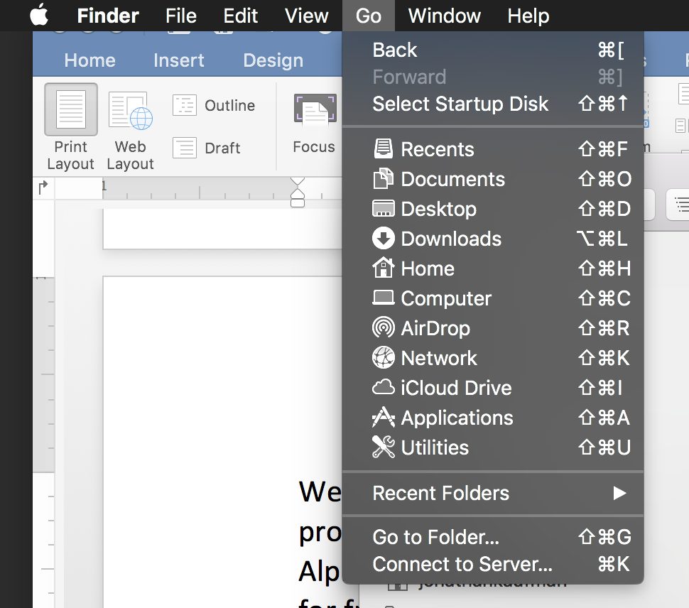

Then choose the “Utilities” menu item in the drop-down list. Note the utilities can also be opened with shift-command-U. When doing so, you should get a folder with similar contants as shown in figure TK.

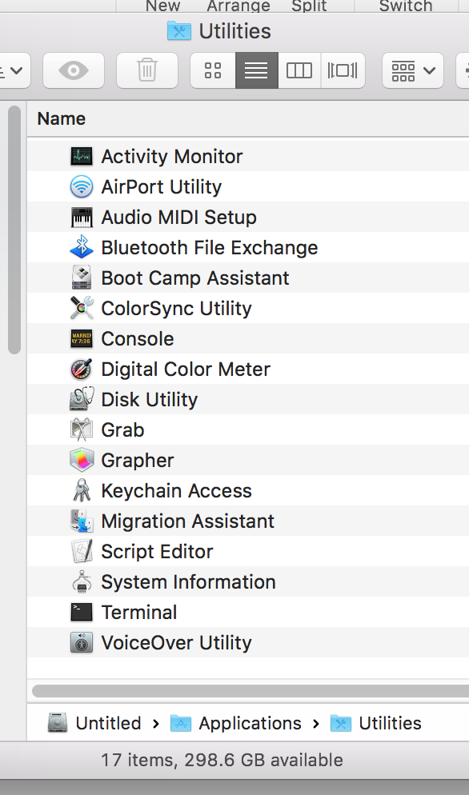

Double-click the Terminal icon to open a terminal window. This terminal window will provide the command-line for the Shasta! command line interface (CLI).

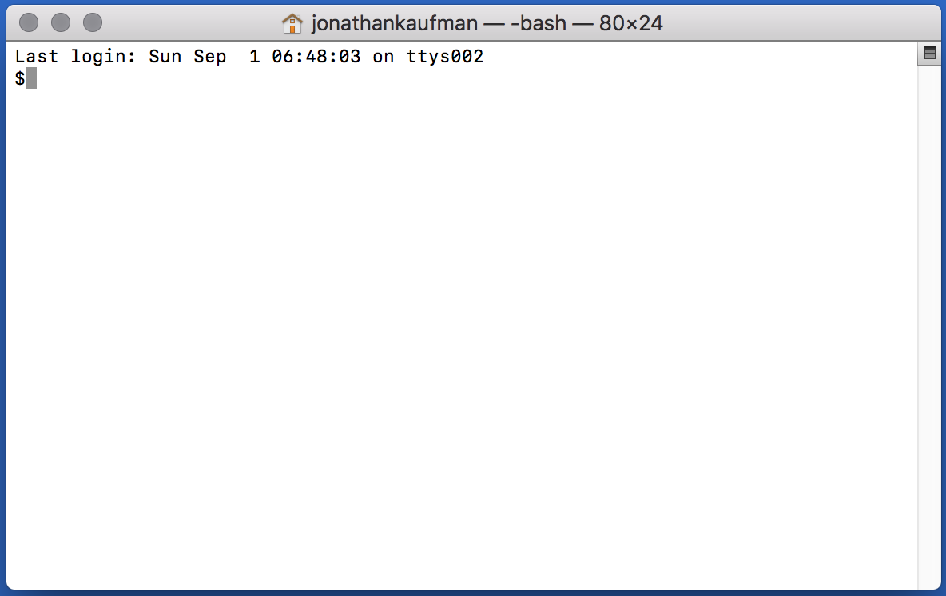

First, however, we need to navigate our terminal window to the folder where the Shasta! application is located. This can be accomplished with the unix **cd** (cd for change directory) command. On my computer, the location is

$cd /Users/jonathankaufman/Dropbox/shasta

Note that the “**$**” is the unix prompt at the command line window. This prompt will vary depending on you computer’s settings. You should navigate to where you put the folder containing the Shasta! application as well as its associated data files. Then, once your terminal command line displays the correct folder location (which can be checked with the **pwd** (print working directory) command), you can initiate the Shasta! Application with the following commend.

$java –jar shasta.jar

The use of the java command indicates that Shasta! Currently runs on the Java Virtual Machine (JVM). If Java is not installed on you computer, the java command will of course not work. To install the latest version of Java on your computer, see the detailed instructions located at java.com.

If Java and Shasta! are correctly installed, the following prompt should appear when you first launch the Shasta! program using the java command indicated above.

Welcome to Shasta!

******************

(For help, enter .h (including the dot) at the prompt >)

top>

The “top>” character is the top-level prompt where you provide instructions to Shasta!. Most commands at this prompt begin with the period symbol “**.**” For example, if you want to see a list of companies within a specific market cap range (or window), use the *window* command which is simply **.w** followed by the *low* and *high* limits of the range (in millions USD) . So, for example, the command

top> .w 100 200

provides a list of companies within the market cap range from $100 million to $200 million. When doing so, the Shasta system change state. This is evident by the new prompt which looks like

:fresh>

The colon indicates that we are no longer in the top-level state of Shasta!, but are alternatively in a collection. The word **fresh** in the prompt indicates that the name of the collection that is loaded is “fresh.” This is the default name. You can create a name for any collection that is in focus using the **.s** (save) command.

:fresh> .s green

:green>

Here we see that the **.s green** *command* named the collection “green,” and the temporary name, “fresh,” remains available for the generation of new collection. Use **.l** (l for list) to get a list items in a collection (the same **.l** command provides a list of collection names when used at the top level), and use **.h** (h for help) to get a list of additional commands.

If a *command* is not preceeded by a “**.**” Shasta! interprets the text to be either a symbol name or the name of a named collection – and brings such symbol or collection into focus. Assuming we typed in the symbol mrk at the prompt, the prompt updates and now starts with a “.” Rather than a “:”. The “.” At the beginning of the prompt indicates that the Shasta! focus is now on a single company rather than a collection of companies (which would be indicated by the promt starting with a “:”. And also the symbol for this single company is displayed in the prompt so that the Shasta! user can be aware of state.

top> .w 100 200

:fresh> .s green

:green> mrk

.MRK>

When Shasta! has a single company in focus, additional “**.**”-preceeded commands are available that provide data on the company in focus. For example, to find the cash position, use **.c**, and for the market cap, use **.mkt**. The complete list of such commands is shown when typing **.h** at the prompt when a single company is in focus (which as mentioned is indicated by the prompt beginning with a “**.**” rather than “**:**”).

**Making Tables**

Collections can be transformed into tables using the **.m** (m for map) command when a collection is in focus. Let’s say we have a collection named fresh and it is in focus. (A simple way to obtain such state is to give the **.w** (w for window) command at the top level). You can obtain a table of say each company’s market cap and cash position as follows.

:fresh> .m c mkt

t c mkt

CRNX 163 634

AKBA 321 714

LXRX 160 747

KURA 178 590

SRNE 168 614

CTST 52 556

VKTX 301 600

Here we have “mapped” (using **.m** command) the functions **c** for cash and **mkt** for market cap. Notice that unlike the **.m** command, the **c** and **mkt** functions are not preceeded with a “**.**”. We can have any number of functions we like. The following table simply adds volume data.

:fresh> .m c mkt v

t c mkt v

CRNX 163 634 0.88

AKBA 321 714 5.06

LXRX 160 747 0.89

KURA 178 590 2.47

SRNE 168 614 4.11

CTST 52 556 6.51

VKTX 301 600 26.56

Notice how potential outliers can be obtained with such tables, witness the volume for VKTX. We can explore if that may be related to revenue as follows.

:fresh> .m c mkt v r

t c mkt v r

CRNX 163 634 0.88 0

AKBA 321 714 5.06 207

LXRX 160 747 0.89 63

KURA 178 590 2.47 0

SRNE 168 614 4.11 21

CTST 52 556 6.51 35

VKTX 301 600 26.56 0

Here we discover no link to revenue between revenue and volume in this collection. We may be interested in mapping arithmatic combinations of these functions. For example, the cash to market cap ratio. This goal can be accomplished by putting the desired arithmatic operator (**+**, **-**, **\***,or **!**) between the two functions. Notice importantly that we use the symbol **!** for division rather than a slash. Here’s how simple is it to create the table.

:fresh> .m c mkt v c!mkt

t c mkt v c!mkt

CRNX 163 634 0.88 0.25

AKBA 321 714 5.06 0.44

LXRX 160 747 0.89 0.21

KURA 178 590 2.47 0.3

SRNE 168 614 4.11 0.27

CTST 52 556 6.51 0.09

VKTX 301 600 26.56 0.5

Sometimes the cash over market cap **c!mkt** values significantly exceed 1. This is usually only for microcap companies and/or companies that have completely lost the value of other assets (say with the failure of a clinical trial). Here, in this collection, the highest is 0.5 for VKTX. We can get additional information on a single security when a collection is in focus by simply including the functions after the security name when responding to the collection prompt. For example, suppose we want a list of institutional ownership for VKTX. We can use the **io** command.

:fresh> vktx io

2019 Vanguard_Group_Inc__Subfiler_

2019 State_Street_Corp

2019 Sio_Capital_Management_LLC

2019 Park_West_Asset_Management_LLC

2019 Northern_Trust_Corp

2019 Fiera_Capital_Corp

2019 Fidelity_Management_&_Research_Co

2019 BlackRock_Institutional_Trust_Co_NA

2019 BlackRock_Fund_Advisors

2019 ArrowMark_Colorado_Holdings_LLC

Or perhaps we are interested in financing cash flow (**cffd** cash flow financing detail).

:fresh> vktx cffd

20190630 0.26

20190331 0.32

20181231 0.34

20180930 167.48

20180630 70.14

20180331 62.29

20171231 14.76

20170930 1.11

20170630 4.0

20170331 2.52

20161231 1.03

20160930 0.1

Here we see a history of financing cash flow by quarter, the largest such cash flow ocurring in the quarter ending September 30, 2018. Suppose you want a function that provides an indication of the extent of financing cash flow to be used in the **.m** function when creating a table. For this purpose, you can use the scalar-value **cff** instead of **cffd**, as follows.

:fresh> .m c mkt cff

t c mkt cff

CRNX 163 634 170

AKBA 321 714 212

LXRX 160 747 147

KURA 178 590 296

SRNE 168 614 436

CTST 52 556 127

VKTX 301 600 324

Here, the **cff** function *reduces* the result of **cffd** so that its result can be used as a single number, which is a requirement for creating a simple table and thus a requirement for use in the **.m** command at a collection prompt. In this case, the sum of all the reported quarterly cash flows is provided. A list of such functions can be obtained at the command prompt by typing the composite help command **.h cmd**.

**Exploring Symbols**

Suppose you want to focus on a single company for exploration of various functions or data that cannot be succinctly represented on maps. Then by all means, as mentioned above at the end of the “Getting Started” section, simply enter the symbol for the company without including any function in the command. Let’s do that for AKBA.

:fresh> akba

.AKBA>

Notice that the prompt subsequently begins with a “**.**” and not a “**:**”. This is the indicator that we have a single company in focus rather than a named collection of companies. Now that we have a single company in focus, we can use all of the company-focused functions directly by treating them as *commands*, and preceeding them with the “**.**” symbol.

Let’s try simply showing the cash position. Now be careful to use **.c** instead of just **c** . If you leave out the **.** before the **c**, Shasta will think you want to look at a company that has the symbol **C**, which currently happens to be Citigroup.

.AKBA> .c

321

.AKBA> c

.C> .cname

Citigroup

As we would expect, returning to an existing *named group* (or the most recent version of the automatically generated **fresh** *group*) is as easy as typing the name of the *group* at the prompt.

.C> fresh

:fresh>

You can also return to the most recent group that was in focus with the **.u** (u for up) *command*. This *command* will also return Shasta!’s focus to **top>**, if that was the focus prior to the *company* focus. Using the **.u** command when the focus is on a collection will also bring Shasta!’s focus to **top>**.

**Yahoo, Edgar, and Company Websites**

One of Shasta’a design principles is to not reinvent the wheel. If there is a free service available that offers dynamic price history charts such as yahoo finance, why re-invent that? Shasta will simply open a yahoo chart window for you with the **.yahoo** command. This command can be used at a symbol-focused prompt, or it can be used without the preceeding **.** if it is preceeded by the symbol name at the **top>** and/or **:collection>** *level* prompts.

Similarly, Shasta! will open the relevant www.sec.gov website page in response to the **.sec** command. Regarding both of these convenience *commands*, in practice, they are much faster and easier to use than the alternative of manually navigating a browser window/tab to the desired page. These as well as the **.oweb** command that opens a browser window to the desired company’s website where additional basic information can be found. These commands are often the fastest way navigate to the exact websites of interest.